**ADMB/TMB Full Installation for Windows**

Written by, and if you have questions or corrections contact:

Charlie Belinsky

Quantitative Fisheries Center

Michigan State University

[belinsky@msu.edu](mailto:belinsky@msu.edu)

517-355-0126

Note: Mac installation of this software is much more involved – contact Charlie for instructions.

[The newest version of this file is on Github](https://github.com/QFCatMSU/OnlineClassBackEnd/raw/master/Windows--ADMB-TMB-EMACS%20Installation%20(replaces%20ADStudio).docx)

These procedures install the following software and was tested on 8/17/22:

* R 4.2.1
* Rtools 4.2
* RStudio 2022.07.1 Build 554
* TMB package for R 1.9.1
* ADMB 13.0
* Emacs 27.2 (Emacs version 28 does not work)

**Admin access to your computer**

The installation procedures will do the following that might require administrative access to your computer:

* Install programs (R, RStudio, Rtools, ADMB, Emacs)
* Install programs directly to the **C:** drive (ADMB, RTools)
* Change the User Environment variables (PATH_6-3.bat)
* Install programs not validated by Microsoft (ADMB, PATH_6-3.bat)

**Viewing hidden files and extensions (optional but very useful):**

To complete this installation, it would help to be able to see hidden files on your computer – this is also helpful for any kind of programming.

To see hidden files and file extensions:

1. Open a File Explorer window
2. Windows 10: Click ***View*** à ***Options*** à ***Change folder and search options*** (figure 1a)

Windows 11: click 3 dots **( … ) à *Options*** (figure 1b)

1. Click ***View*** tab (figure 2)
   1. Check ***Show hidden files…***
   2. Uncheck ***Hide extensions for known file types***
   3. click ***OK***

**Installation of ADMB and TMB (all installations use default options):**

Steps 1, 3, and 4 are only needed for TMB, and Step 5 is only needed for ADMB. All other steps are required for both ADMB and TMB.

1. [Download](https://cran.r-project.org/bin/windows/base/) and Install R (you need to have at least version 4.2)
2. [Download](https://cran.r-project.org/bin/windows/Rtools/rtools42/rtools.html) and install Rtools42 (version 4 part 2)
   * Click on ***Rrools42 Installer*** in ***Installing Rtools42*** section
3. [Download](https://www.rstudio.com/products/rstudio/download/#download) and install RStudio (you need to have a version from 2022 or later)
4. Open RStudio and install the TMB package
   * Tools à Install Packages… à TMB (in ***Packages*** textbox) à Install
   * Close RStudio after installing package
5. [Download](http://www.admb-project.org/downloads/admb-13.0/QuickStartWindows.html) and install ***ADMB-13.0-windows.exe***
   * + Alternatively, you can [download](http://www.admb-project.org/downloads/admb-12.3/) ADMB-12.3-windows.exe (under ***Windows*** header)
     + You will likely get a ***Windows protected your PC*** screen, if so:
       1. click ***More info***
       2. click ***Run anyway***
6. [Download](http://ftpmirror.gnu.org/emacs/windows/emacs-27) and install ***emacs-27.2-x86_64-installer.exe***
7. [Download](https://drive.google.com/file/d/1TFi7nuJFbsn8Nhy4ot3MoRCsJ0T7erCI/view?usp=sharing) ***PATH_v6-3.zip***
   * Unzip ***PATH_v6-3.zip*** (Right-click, ***Extract All***), which contains
     + An executable file called ***PATH_v6-3.bat***
     + A folder called ***emacsConfigFiles*** that gets installed to the home directory when PATH_v6-3.bat is executed
     + A folder called ***Examples***, which contains ADMB and TMB scripts that can be tested in Emacs.
   * Execute (double-click) ***Path_v6.bat***
     + You will likely get a ***Windows protected your PC*** screen, if so:
8. click ***More info***
9. click ***Run anyway***
10. Restart computer

**Have tpl files open by default in Emacs (this would also work for cpp files)**

* Right-click on any ***\*.tpl*** file
* Choose ***Open With***
* Windows 10:
  + go to bottom and click on ***More Apps***
  + At bottom, click ***Look for another app on this PC***
  + The Path is: C:\Program Files\Emacs\x86_64\bin\emacs.exe
  + Click ***OK***
* Windows 11: click ***Choose another app***
  + At bottom, click ***Choose an app on your PC***
  + The Path is: C:\Program Files\Emacs\x86_64\bin\emacs.exe
  + Click ***Open***
  + Click ***Always***

**Testing out ADMB:**

* In folder you just unzipped, double-click ***emacs à examples à simple à simple.tpl***
* Open ***simple.tpl*** in ***Emacs***
* Click ***Translate*** (button 1), ***Build*** (button 2), and ***Run*** (button 3)
  + Make sure you wait for steps to complete
* If the Emacs panels look like this after ***Run,*** then ADMB is properly installed:

**Testing out TMB:**

* In folder you just unzipped, double-click ***emacs*** à ***examples*** à ***mini*** à ***mini.cpp***
* Open ***mini.cpp*** in ***Emacs***
* Click ***Clean*** (button 1), ***Compile*** (button 2), and ***Run*** (button 3)
  + Make sure you wait for step to complete
  + ***Compile*** take a minute or two and gives lots of warnings
* If the Emacs panels look like this after ***Run,*** then TMB is properly installed:

**Figures:**

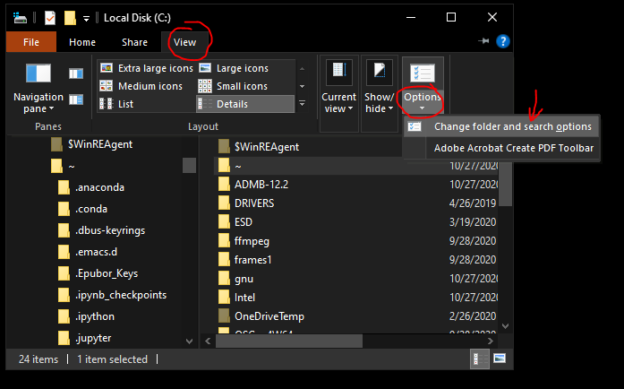

Figure 1a: Opening the Folder Options window (Windows 10) -- go back to instructions

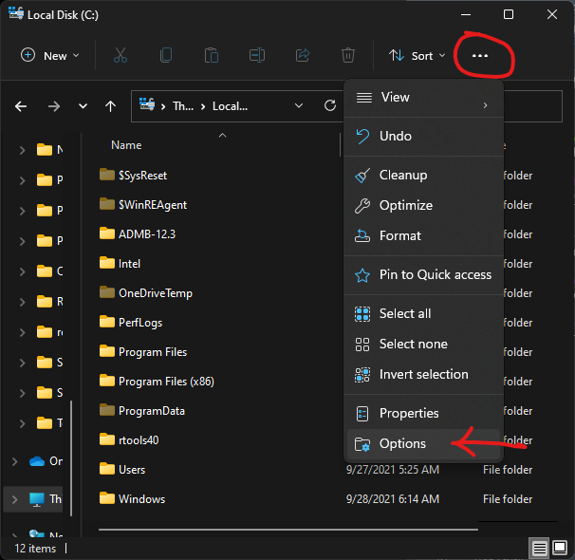

Figure 1b: Opening the Folder Options window (Windows 11) -- go back to instructions

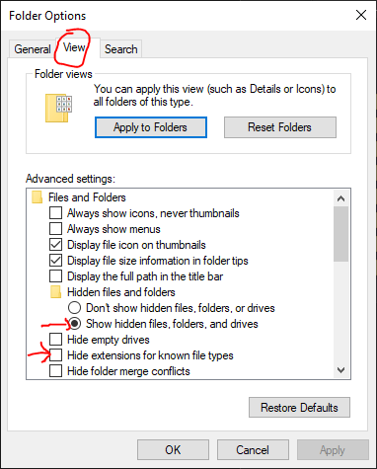

Figure 2: Folder options to change – go back to instructions

**Notes:**

1. The batch file ***PATH_v6-3.bat*** adds the following five folders to the ***User*** ***Environment PATH*** variable:

* c:\Program Files\R\R-***X.X.X***\bin; // currently R-4.2.1
* c:\Program Files\R\R-***X.X.X***\bin\x64; // currently R-4.2.1
* c:\admb-XX.X\utilities\mingw64\bin; // currently admb-13.0
* c:\rtoolsXX\usr\bin; // currently rtools42
* c:\admb-XX.X\bin; // currently admb-13.0

The folders can be manually added – information is in the Appendix. A lot of the functionality of the User Environment has been moved elsewhere and I believe that only the third folder path (c:\admb-XX.X\utilities\mingw64\bin) is still needed in the User Environment – but I have not fully tested this out yet.

1. **If you update ADMB** (a very rare occurrence), you will need to modify the PATH to reflect the new version – otherwise you will run the old version. This can be done by executing the ***PATH_v6-3.bat*** file.
2. There is a Mac version of these installation, but the Mac version is much more involved and requires Terminal access. Contact Charlie for the Mac instructions.

**Appendix – Manually do wha****t Path_v6-3.bat does:**

Path_v6-3.bat does two things that can both be done manually:

1. prepends 5 locations to the User’s ***Environment Variables***
2. Copies the ***Emacs*** configuration files to the user’s ***AppData*** folder

I prepend the locations because I do not want to delete any of the current PATH locations, but I want these five locations to take priority. For instance, there might already be a g++ compiler in an older PATH location and I want to be sure the newest compiler is chosen.

**Prepending locations to the User PATH Environment Variable**

The five location we are adding are:

* c:\Program Files\R\R-4.2.1\bin; // used in emacs to find R executable for TMB
* c:\Program Files\R\R-4.2.1\bin\x64;
* c:\admb-13.0\utilities\mingw64\bin; // used in ADMB to find g++ compiler -- needed
* c:\rtools42\usr\bin; // used by TMB to find make.exe
* c:\admb-13.0\bin; // used by emacs to find ADMB (has to go last)

Note: Much of the functionality of the PATH Environment Variables has moved elsewhere and I think that only the 3rd path is still needed – but I have not fully tested this out yet.

You can manually add the five locations to the Users Path by:

1. Go to ***Start*** à ***Settings***
2. In ***Find a setting*** textbox start typing ***Environment***
3. Click on ***Edit environment variables for your User account***
4. If Path is NOT in the ***User variables for***… list, then
   1. Click ***New...***
   2. Variable Name: ***Path***
   3. Variable Value: Add the four locations – make sure you keep the semicolon in to separate them
5. If Path is in the ***User variables for…*** list, then
   1. click on ***Path***
   2. click ***Edit…***
   3. Add the four locations to the beginning of the list and click ***OK***

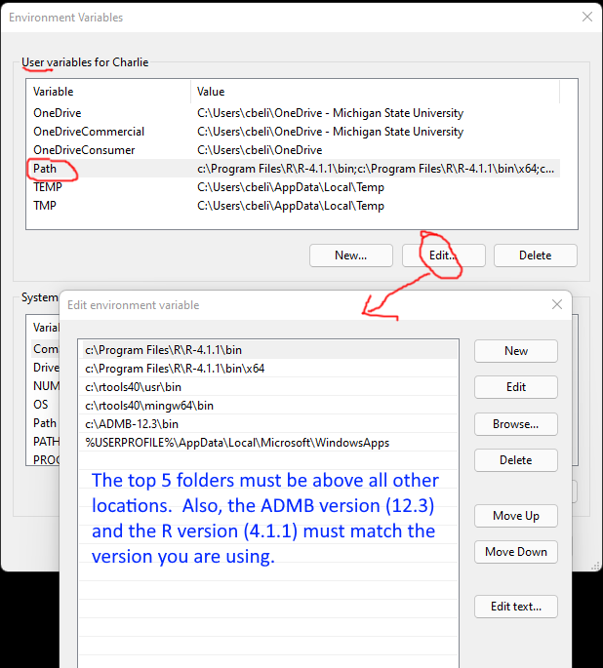

Add locations to the User Path – steps 3 and 5 (old image – from when there were 5 folders to add)

**Copy emacs config files to AppData**

Inside ***Path_v6-3.zip***, there is a folder named ***emacsConfigFiles***.  You need to copy the contents inside the emacsConfigFiles folder (a file named ***.emacs*** and a folder named ***emacs***) to the user’s ***appdata*** folder.

The easiest way to get to the ***appdata*** folder is to type **%appdata%** in a File Explorer window and hit enter.  Or, you can go to the folder: C:\Users\<yourUserName>\AppData\Roaming

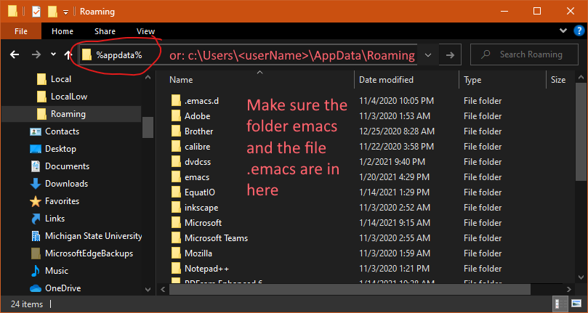

File Explorer Window opened to the AppData folder – copy ***.emacs*** and the ***emacs*** folder here

**Future changes to document:**

* Check which PATH variables are still needed – need to fully test
* Explain how my version of ***.emacs*** is finding the PATH folders now.